#####Page break

## Lifestyle and Risk Factors

###Summary

Mental and physical wellbeing has close ties with people’s lifestyles and behaviours. Financial security, employment and location are influences that often have a bearing on these choices. Issues can develop when alcohol, smoking or drug use shape lives. This section provides data on drug-related hospital admissions, alcohol-related hospital admissions, alcohol-specific deaths and bowel screening uptake, to give an overview of some of the lifestyles and behaviours for Highland HSCP. These can give an idea of quality of life and prosperity.

**For the most recent time periods available3, Highland had:**

* **543** alcohol-related hospital admissions per 100,000 age-sex standardised population. This is lower than Scotland (611 admissions per 100,000)4.
* **21.9** alcohol-specific deaths per 100,000 age-sex standardised population. This is higher than Scotand (21.1 deaths per 100,000)4.
* **129** drug-related hospital admissions per 100,000 age-sex standardised population. This is lower than Scotland (228 admissions per 100,000)4.
* **70.2%** uptake of bowel screening among eligible population, compared to 65.6% in Scotland.

###Alcohol-related Hospital Admissions

In 2021/22, the rate of alcohol-related admissions was **543** per 100,000 age-sex standardised population in Highland. This is a 50.5% decrease overall since 2002/03. Figure 1 shows a trend of alcohol-related hospital admissions for Highland HSCP compared with Scotland, and NHS Highland from financial year 2002/03 to 2021/22.

Figure 2 shows that in 2021/22, Highland HSCP had a lower alcohol-related hospital admissions rate compared to Scotland (543 and 611 admissions respectively).

#####Page break

#### Figure 1: Alcohol-related hospital admission rates by area and over time.

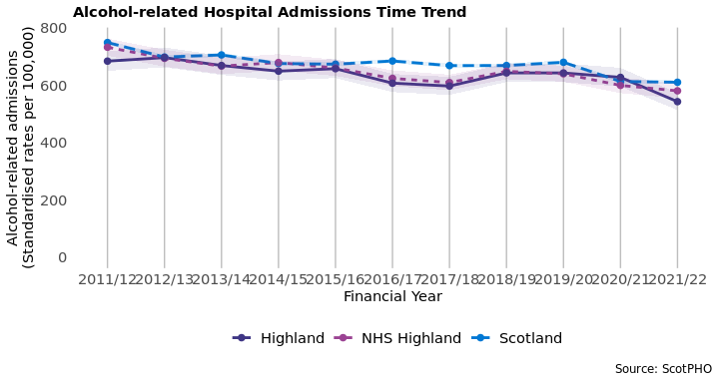

#### Figure 2: Alcohol-related hospital admissions by area for the latest time period.

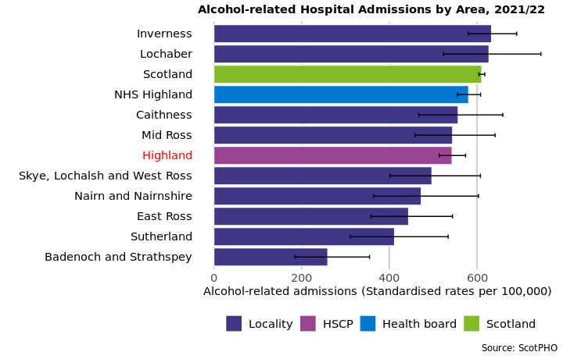

###Alcohol-Specific Deaths

Data on alcohol-specific deaths is available as 5-year aggregates. In Highland, the latest rate of alcohol-specific deaths was **21.9** deaths per 100,000 age-sex standardised population. This is 18.3% lower than the rate in 2002 - 2006. Figure 4 also shows that the HSCP has a higher alcohol-specific death rate compared to Scotland overall (21.1 deaths per 100,000).

#### Figure 3: Alcohol-specific deaths by area and over time.

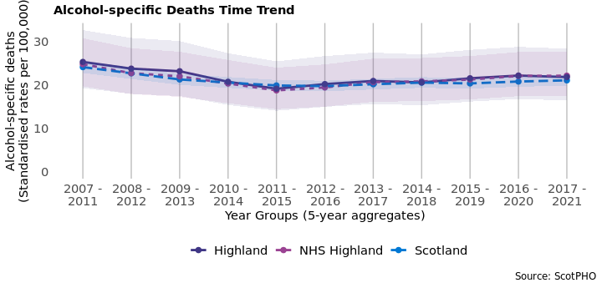

#### Figure 4: Alcohol-specific deaths by area for the latest time period available.

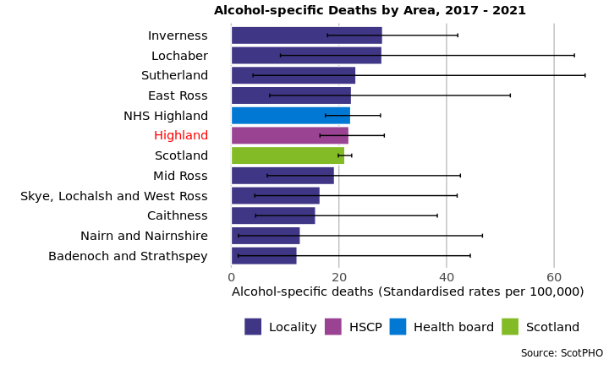

###Drug-related Hospital Admissions

There were **129** drug-related hospital admissions per 100,000 age-sex standardised population4 in Highland HSCP in the time period 2019/20 - 2021/22 (3-year financial year aggregate). This is a 199% increase since 2002/03 - 2004/05. A trend of the change in drug-related hospital admissions for the HSCP and comparable areas is shown in figure 5 from 2002/03 - 2004/05 onwards.

A comparison of areas at the most recent time period (2019/20 - 2021/22 aggregated financial years) is available in figure 6. This shows Highland HSCP has a lower rate of drug-related hospital admissions than Scotland (228 admissions per 100,000).

#### Figure 5: Drug-related hospital admission rates by area and over time.

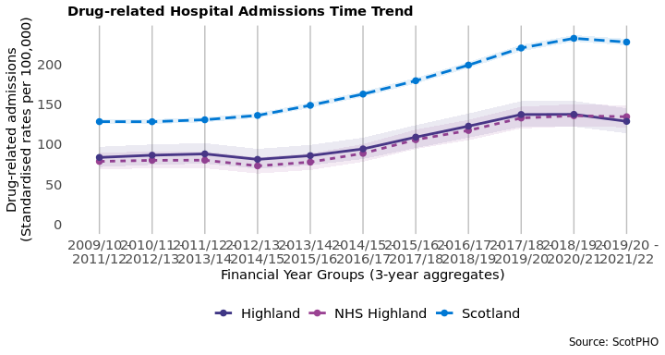

#####Page break

#### Figure 6: Drug-related hospital admission rates by area for the latest time period available.

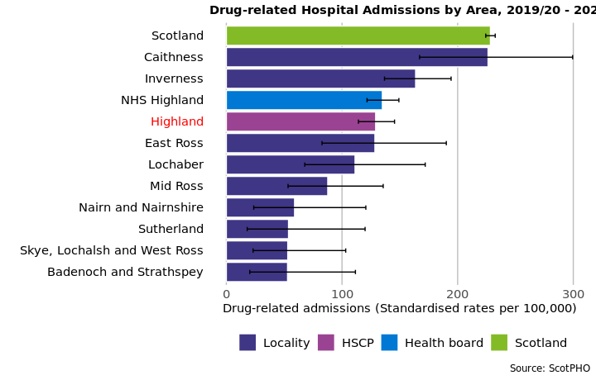

###Bowel Screening Uptake

Bowel screening is offered every two years to eligible men and women aged between 50-74 years old. Eligible people are posted a test kit which is completed at home. Since 1st April 2013, those aged 75 and over can also self-refer and opt into screening.

A trend of the percentage uptake of bowel screening among the eligible population is shown for HSCP and comparable areas. Data is suppressed into 3-year aggregates. The 2019 - 2021 uptake rate for Highland is **70.2%**. This is a 17.7% increase since 2008 - 2010. As can be seen in figure 8, in the latest estimate, the uptake in Highland was higher than the uptake in Scotland overall (65.6%).

##### Page break

#### Figure 7: Bowel screening uptake for eligible men and women, by area and over time.

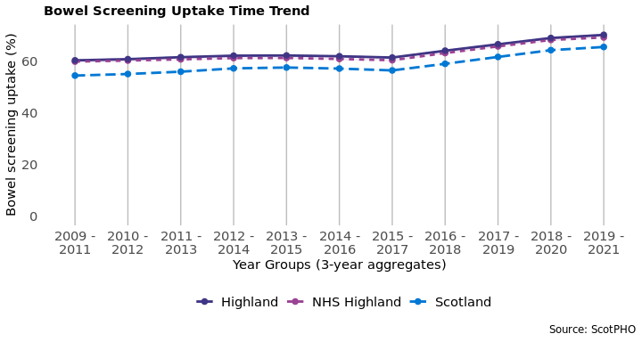

#### Figure 8: Bowel screening uptake by area for the latest time period available.

